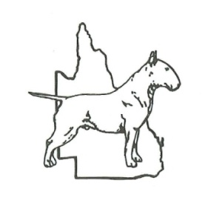
APPLICATION FOR MEMBERSHIP OF
THE BULL TERRIER CLUB OF QUEENSLAND Inc.
CONSTITUTION OF INCORPORATION AFFILIATES – APPLICATION FOR MEMBERSHIP.
9 (b) every applicant for any class of membership of the affiliate shall be proposed by one member of the affiliate and seconded by another member. The application for membership shall be made in writing, signed by the applicant and has a proposer and seconder and shall be in such form as the management committee from time to time prescribes.
(c) An application for membership shall be accompanied by the prescribed fees.
FORWARD TO: The Bull Terrier Club of Qld Inc
The Secretary
Email to – qldbullterrierclub@gmail.com

Financial Year Commences 1st January (New members joining after the1st October shall retain full membership until the 31st December of the following year).
ANNUAL SUBSCRIPTION: (Please tick appropriate box’s)
JOINING FEE $10.00 (payable once only)
MEMBER (ordinary) (a) $25.00
DUAL MEMBER (b) $30.00 (same address)
HONORARY MEMBER No Fees Applicable
LIFE MEMBER No Fees Applicable
JUNIOR $10.00 (10 – 16 years of age)
JUNIOR Joining with (a) (b) $ 5.00
BREEDERS DIRECTORY $20.00 for 12 months. (5 lines) payable with renewals.

Membership $$ can be direct debited straight into our account. If doing this please put your surname as the reference and forward this completed form to the above address. BSB 484-799 A/C # 602294990

I/We________________________________________________________________________________ (print name/s)
Of____________________________________________________________________(Address)________________Postcode
Phone:________________________Mobile:_____________________Email:________________________________________
Breed:____________________________________(Membership is not restricted to dog owners, but all members are expected to uphold the aims of the club at all times)
I /We hereby apply for RENEWAL of membership / NEW MEMBERSHIP of The Bull Terrier Club of Qld Inc, and if accepted by the first available General Meeting of members will abide by the Constitution and By-Laws of the club.
I/We declare that I/we am/are NOT under suspension by any Australian Controlling Body or other Affiliate. DECLARATION
ALL MEMBERS AGREE TO ABIDE BY DOGS QLD RULES, INCLUDING THE CODE OF ETHICS AND THE BULL TERRIER CLUB OF QUEENSLAND INC. BY-LAWS AS AT THE 19TH JANUARY 2008.
SIGNED: ________________________________/________________________________DATE: _________________
Photocopies of application forms will be accepted but must be completed in ink.
…………………………………………………………………………………………………………………………………………

